Day 2: problems

Codility

<https://app.codility.com/demo/results/trainingSTVX9M-48B/>

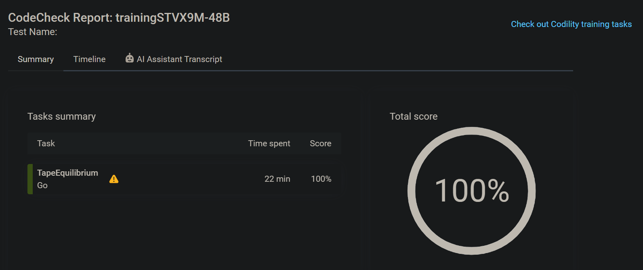

<https://app.codility.com/demo/results/trainingAB49CZ-J52/>

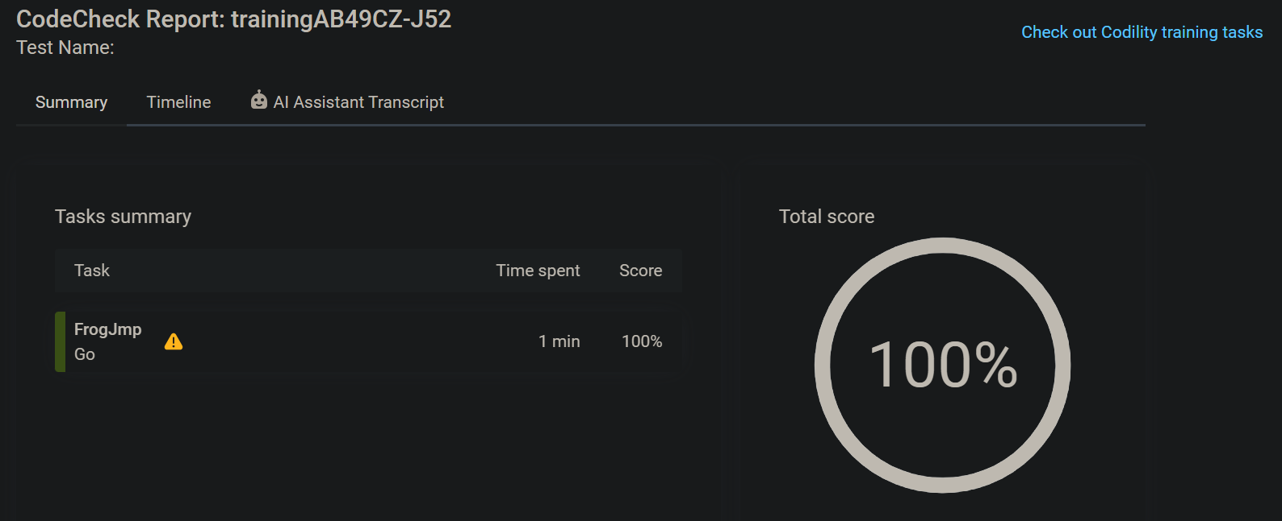

<https://app.codility.com/demo/results/training2FYU7W-EE3/>

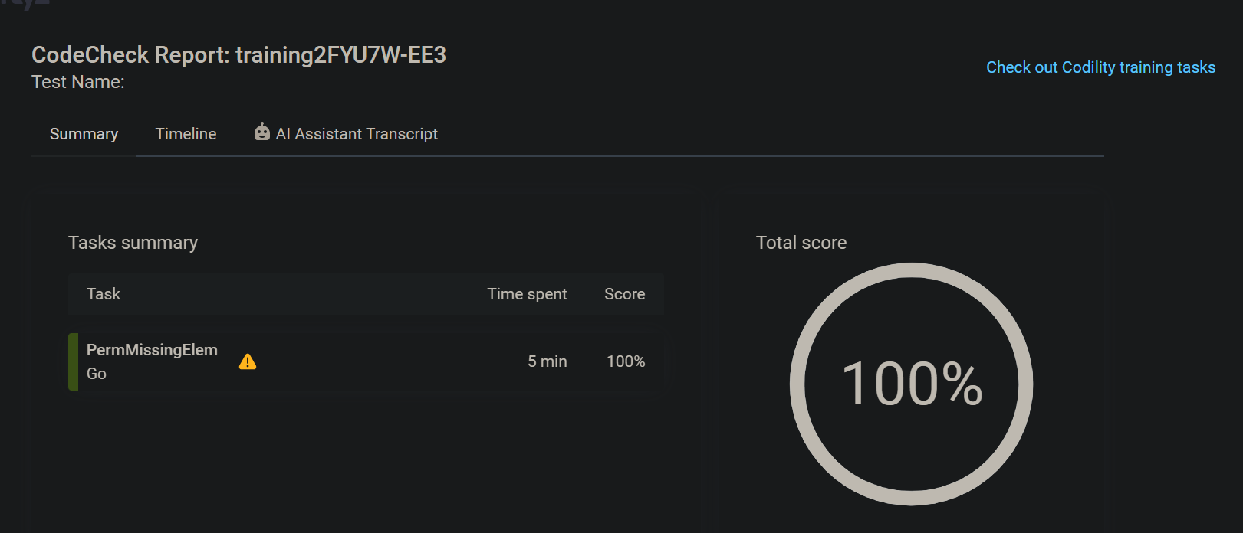

<https://app.codility.com/demo/results/trainingBG7ENC-FMU/>

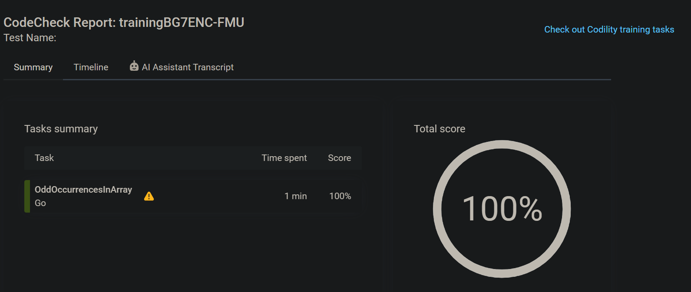

<https://app.codility.com/demo/results/trainingZEGXUY-42Z/>

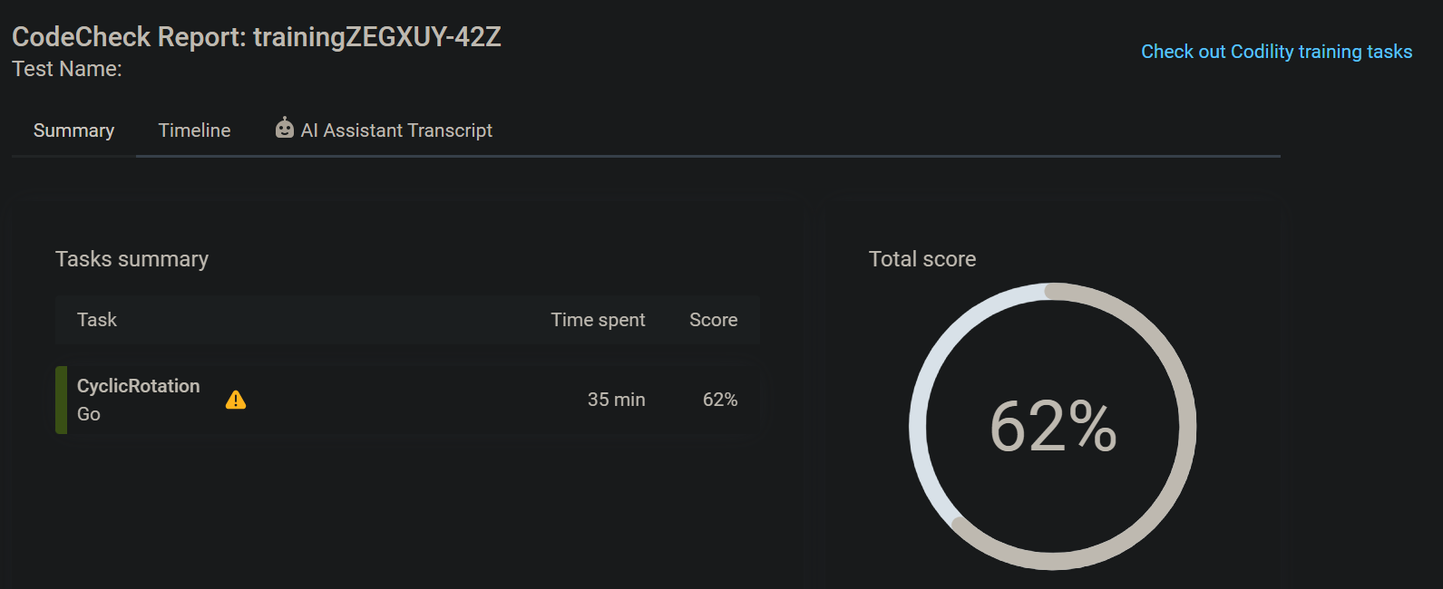

<https://app.codility.com/demo/results/trainingDUREJ9-23S/>

